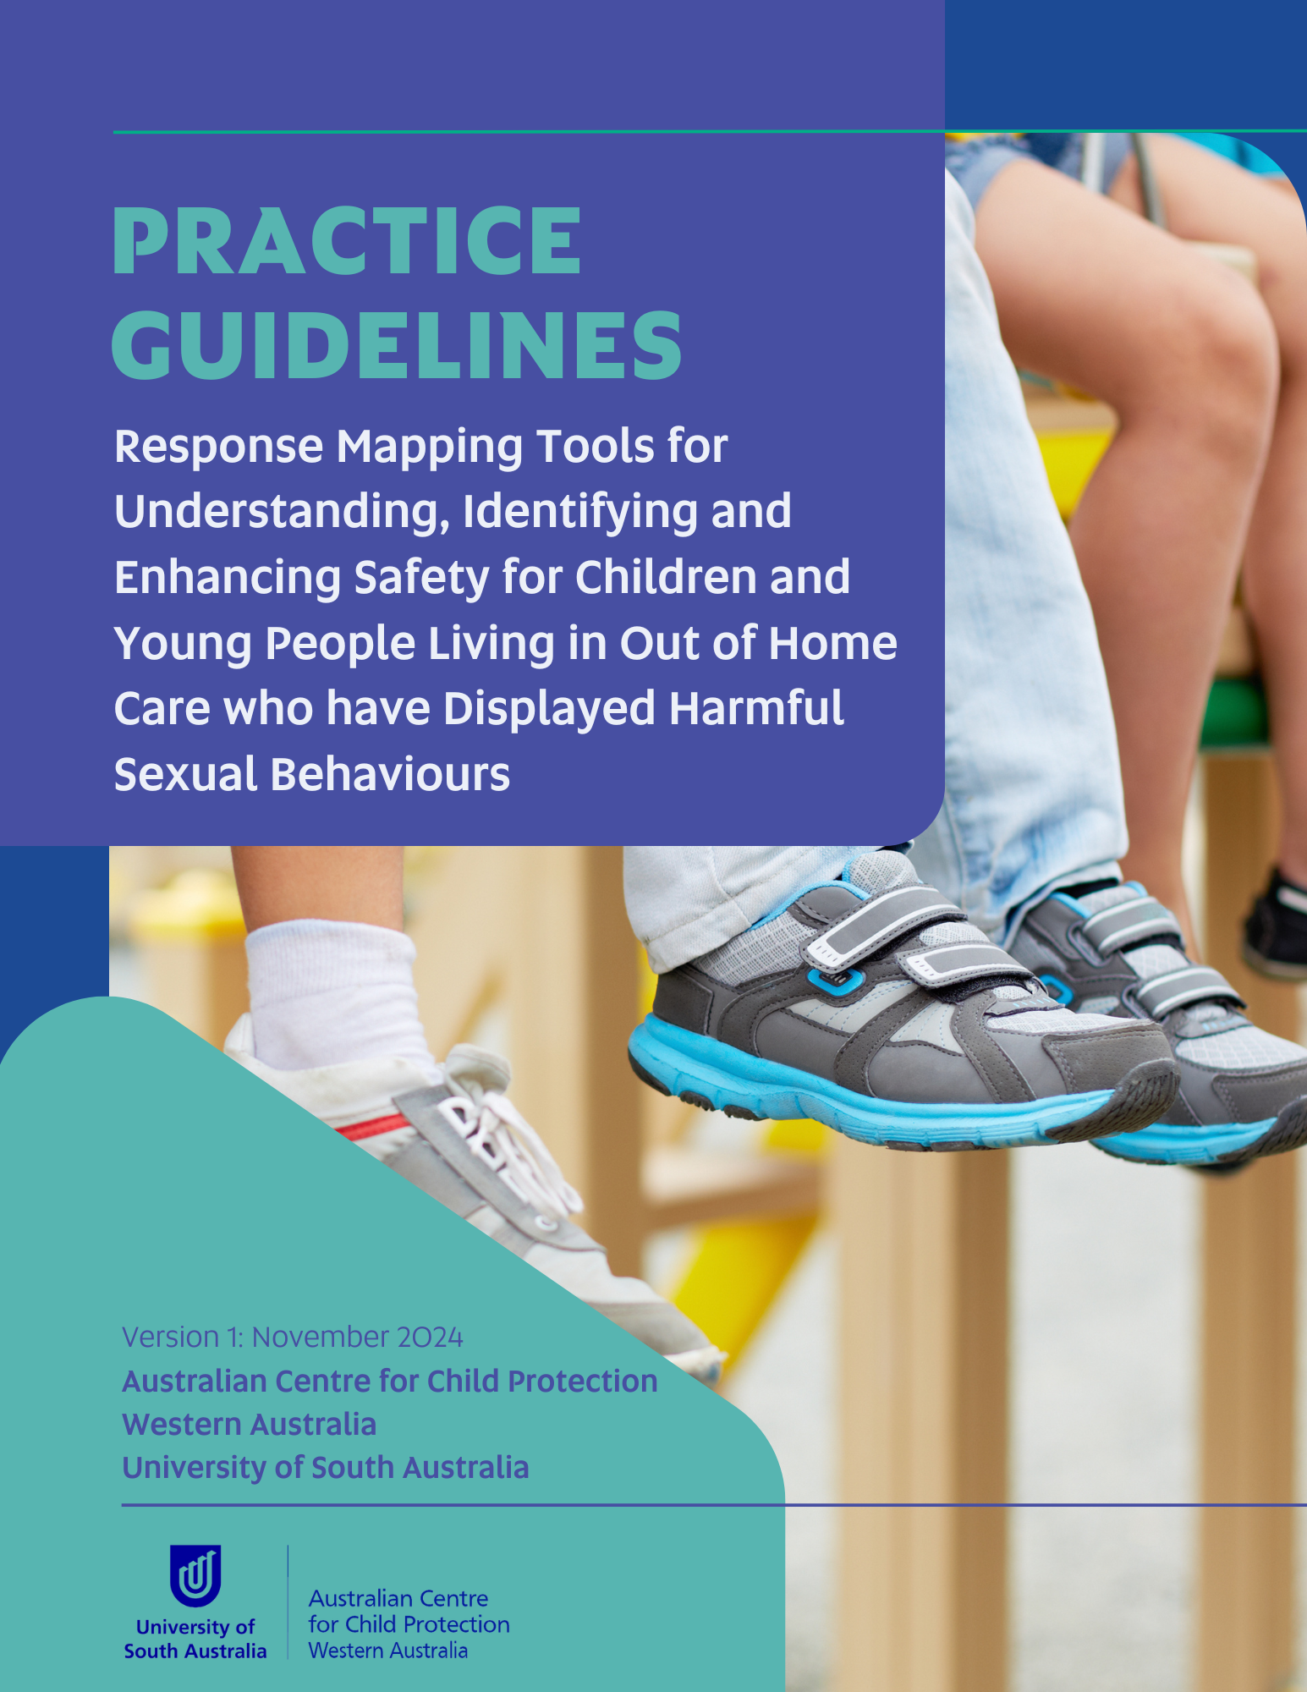
© University of South Australia 2024.

Acknowledgements
The Department of Communities and the Australian Centre for Child Protection proudly acknowledge Traditional Custodians throughout Western Australia and recognises their continuing connection to their lands, families, and communities. We pay our respects to Aboriginal and Torres Strait Islander people and cultures, and to Elders past and present.

Funding
This work was supported by funding from the Government of Western Australia Department of Communities as a project within the Harmful Sexual Behaviours Solutions Grant. Special thanks to the collaboration with the Royal Commission Implementation Team and the Specialist Child Protection Unit.

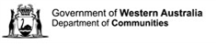
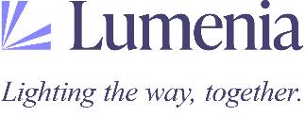
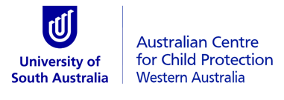

Contributors

Project Team
Amanda Paton, Chief Investigator, Australian Centre for Child Protection
Sian Burgess, Researcher and Practice Lead, Australian Centre for Child Protection
Dr Melissa Kaltner, Research Consultant, Lumenia Consulting
Mark Galvin, Research Consultant, Lumenia Consulting
Koorinya Moreton, Research Consultant, Lumenia Consulting
Professor Leah Bromfield, Adviser, Australian Centre for Child Protection

Co-design Participants
The co-design process for this project involved a diverse group of participants from both government and non-government agencies. Participants held a variety of child focussed roles within the out of home care (OOHC) space, including carers, case managers, team leaders, cultural advisors, psychologists, managers, and directors.

Expert group
The co-design process also benefitted from the knowledge and expertise of a group of subject matter experts in the field of harmful sexual behaviours (HSB) related to clinical practice, research and cultural knowledge.

Suggestion citation
Paton, A., Burgess, S., Kaltner, M., Galvin, M., & Moreton. K., Bromfield, L. (2024). Response Mapping Tools for Understanding, Identifying and Enhancing Safety for Children and Young People living in Out of Home Care who have displayed Harmful Sexual Behaviours: Practice Guidelines. University of South Australia, Australian Centre for Child Protection: Western Australia.

Content Advice
The subject of HSB and child abuse, more generally, can be difficult for many people and may elicit a range of emotional responses, including distress. If you find the contents of this manual confronting or challenging, there are resources available to support you.
It is important that you look after your health and wellbeing. If you find yourself in distress, the best way to respond is to get help. It is important that you seek help as soon as you feel any form of discomfort or stress. Issues causing you stress or trauma are easier to manage when you deal with them early.
When you are in the field dealing with vulnerable children or young people in need, they will be looking to you to be effective and to know what to do. If you are struggling to manage your feelings or have unresolved issues, you will find it hard to support the child or young person effectively.
Remember, taking care of yourself is crucial to being able to take care of others. The following telephone support lines are available to you to access support:
- Lifeline 13 11 14 (all ages)
- 13Yarn 13 92 76
- Beyond Blue 1300 224 636

Clinical warning
These implementation guidelines provide specific direction and tools for working with children and young people who have displayed HSB. However, it is crucial to apply professional judgment and tailor your approach to each individual child and young person, considering their context as well as the boundaries and frameworks within which you work. The information is provided in good faith and should be used in conjunction with existing organisational guidelines, processes, and adherence to legal responsibility.
Supervision and reflective practice are also vital when supporting children and young people who have displayed HSB. Supervision offers a safe space to reflect, seek guidance, and strengthen decision-making, while reflective practice helps you consider your own perspectives and approach, ensuring the child or young person remains at the centre of your work. Regular care team discussions are also key, allowing for shared insights, collaboration, and alignment in supporting the child or young person. Building skills and working together with colleagues and other professionals not only enhances your capability but also ensures a coordinated and thoughtful response to the complex needs of children and young people displaying HSB.

Contents
Acknowledgements 2
Funding 2
Contributors 3
Project Team 3
Co-design Participants 3
Expert group 3
Suggestion citation 3
Content Advice 4
Clinical warning 4
Contents 5
OVERVIEW 6
Using these implementation guidelines 6
Language and Terminology 7
OVERVIEW OF THE RESPONSE MAPPING TOOLS 9
How and why these tools were developed. 11
Principles guiding our practice. 12
Understanding Mandatory Reporting Obligations 13
Cultural Considerations 14
Compassionate Approaches to Response Mapping 14
Other Important Guidelines and Frameworks 15
UNDERSTANDING AND IDENTIFYING HSB 16
Level A Checklist: Identify and Respond 16
Level B Assessment: Review and Enhance 17
Sharing and storing of the tools 17
Key Points to remember: 17
ENHANCING SAFETY 18
The Acute Safety Plan 19
Sharing and Storage of the Resources 19
Key Points to remember: 19
Children and Young Person’s Version of the Safety Plan 20
Sharing and Storage of the Resources 21
Key Points to remember: 21
Enhancing Safety and Wellbeing Plan 22
Sharing and Storage of the Resources 22
Key Points to remember: 22
REFERENCES 23

OVERVIEW

Using these implementation guidelines
These guidelines outline the package of Response Mapping Tools designed for understanding and responding to sexual behaviour displayed by children and young people living in the Out of Home Care (OOHC) setting. While these tools have been specifically developed for application within the OOHC context in Western Australia, various elements could be applied across a range of settings and jurisdictions to support children and young people displaying sexual behaviours that may be harmful - harmful sexual behaviours (HSB).
The guide is structured into four sections, each addressing a critical aspect of the tools:

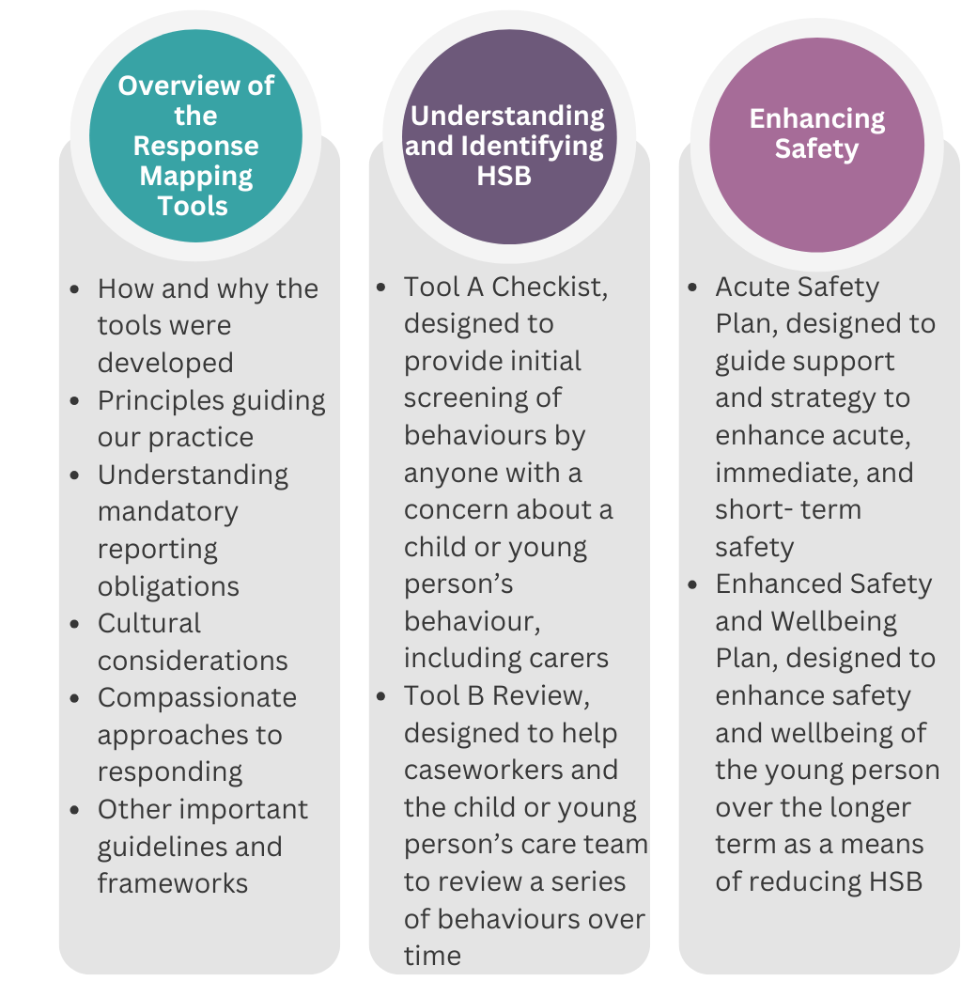

Figure 1: Overview of the structure of the guidelines

Language and Terminology
Acute, Immediate
The terms “acute” and "immediate" refer to actions, decisions, or plans that must be occur without delay, often in response to an urgent situation. In the out-of-home care context, this might refer to the need for actions taken to ensure a child’s safety and wellbeing is protected in the “here and now”, until other short-term or long-term measures can be planned and put in place.
Carer, caregiver
The term "carer" refers to individuals who provide day-to-day care and support for a child or young person living in out-of-home care. Carers may be foster carers, kinship carers (extended family), or residential care workers. Carers play a key role in ensuring the child’s or young person’s emotional, physical, and psychological well-being while they are living away from their birth family.
Care arrangements, placements
"Care arrangements" or "placements" refer to the living situation organised for a child or young person who cannot remain living with their birth family. This may include foster care, kinship care, residential care, or other forms of care as determined by the child or young person’s needs and the legal system. The placement aims to provide a stable and safe environment for the child or young person, either temporarily or permanently.
Care team
A “care team” is the group of people (family, carers, the child or young person (where possible), community members, and professionals) who work together to plan, coordinate and provide day-to-day and long-term support for a child in out-of-home care.
Membership may include parents and extended family, carers, cultural advisors, educators, health practitioners, social workers, and legal representatives, as well as others important to the child. The team shares responsibility for meeting the child’s needs, maintaining their connections to family, culture and community, and supporting their safety, healing, and development.
Case manager
A "case manager" is a professional (usually with qualifications in social work, social care, youth work, or psychology) responsible for overseeing the child’s or young person’s case in out-of-home care. They coordinate services, monitor the child’s placement, ensure their needs are met, and develop care plans in consultation with the child, carers, and care team. The case manager also ensures compliance with legal requirements, and usually serves as the child’s legal guardian.
Children, young people
In these guidelines, the term "children" is used to refer to all individuals under the age of 18. However, recognizing that adolescents often prefer to be identified differently, the term "young people" is also used when appropriate to respect their preferences and acknowledge their evolving identities. This approach ensures that our language is inclusive and sensitive to the needs and preferences of all children and young people.
Long term
"Long term" refers to something that extends over a significant duration, typically lasting months, or years. Long-term plans, in the context of HSB, are usually put in place to address entrenched issues that underly the occurrence of HSB and aim to achieve stability, continuity, and lasting results.
Out of Home Care
"Out of Home Care" (OOHC) refers to the care provided to children and young people who are unable to live with their birth families due to concerns for their safety, welfare, or well-being. In Australia, OOHC includes foster care, kinship care, and residential care. The goal of OOHC is to provide a safe, stable, and nurturing environment while efforts are made to resolve the issues that led to the child’s removal from their family. Some children and young people may live in OOHC temporarily before returning to their family’s care, while others may remain in OOHC for an extended period, sometimes until they turn 18 years of age.
Short term
"Short term" refers to something that is limited in duration, usually lasting a few days, weeks, or months. Short-term plans, in the context of HSB, are often transitional or temporary, requiring regular review to remain relevant and accurate. These plans have a focus on achieving near-term objectives.

OVERVIEW OF THE RESPONSE MAPPING TOOLS
Having the right tools to support carers and case managers working with children and young people in care is important to ensure that children and young people’s health and wellbeing needs are met.
The HSB Response Mapping Tools have been designed to guide people who work with Western Australian children and young people who are residing in out-of-home care (OOHC). They are designed to be used by a range of people in children and young people’s lives who might have concerns about a child or young person’s sexual behaviour, including foster and kinship carers, residential carers, case managers and other professionals.
For the tools, HSB in children and young people includes a spectrum of behaviours that extend beyond developmentally appropriate sexual exploration and curiosity, defined as:
Harmful sexual behaviours are sexual behaviours displayed by children and young people that fall outside what may be considered developmentally, socially, and culturally expected, may cause harm to themselves or others, and occur either face to face and/or via technology.
When these behaviours involve another child or young person, they may include a lack of consent, reciprocity, and mutuality, and may involve the use of coercion, force, or a misuse of power. (Attorney-General’s Department, 2023)
When concerns arise about potentially harmful sexual behaviours displayed by a child in care, these tools can be used to consider if the child’s behaviour is developmentally appropriate or not, to document the behaviour and to build plans to support the child or young person.
Children and young people in care are at a higher risk of displaying and being exposed to HSB compared to their peers. Children and young people are often placed in care due to experiences of abuse, neglect, and trauma. HSB are often displayed when children and young people have not been taught appropriate ways of expressing themselves or managing their traumas and emotions.
These tools utilise the Layered Continuum Model for Understanding and Determining HSB (Paton & Bromfield, 2024), the Department of Communities Framework for Understanding and Responding to HSB (2022), and the Western Australia's state-wide Framework for Understanding and Responding to Harmful Sexual Behaviour (in progress) to support understanding and responding to HSB. These documents provide detailed information on the context of HSB for children and young people in care.
The Response Mapping Tools have been developed through an evidence-informed co-design process. They are designed to support carers, caseworkers and others in a child or young person’s life to consider sexual behaviours of children and young people in their care and:​
- Identify behaviours - Understanding where the behaviour sits along the continuum ​
- Review behaviours – Considering risk associated with the behaviour occurring again ​
- Respond to behaviours - Considering acute safety​ and wellbeing
- Enhance Safety - Enhancing long term safety.

Figure 2 below illustrates the Response Mapping process.

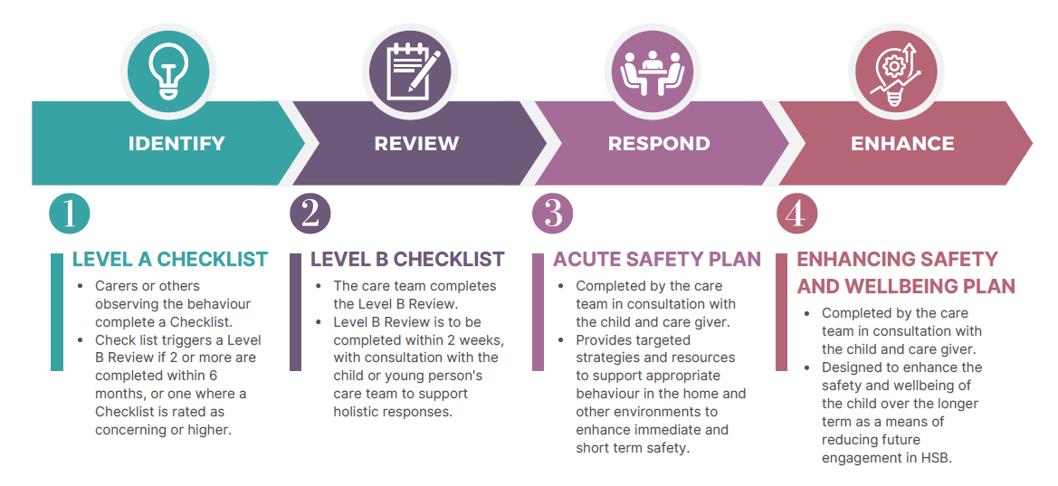
Figure 2: Process flowchart for Response Mapping Tools

There are two separate tools which will support the child’s carer and care team to consider how to respond to sexual behaviour displayed by children and young people. These are called the Level A Checklist and Level B Review and can be found in Part 2 of these guidelines.
The Level A Checklist is designed to assist in evaluating and responding to sexual behaviours – to Identify – and determine if those behaviours are harmful. The carer may undertake multiple reviews of behaviour over time using the Level A Checklist, and as needed the case manager or care team will complete a more thorough Level B Review. The Level B Assessment is a Review aiming to provide a deeper analysis of harmful sexual behaviours that have occurred on multiple occasions or have been identified as harmful using the Level A Checklist (these include those that are Concerning, Very Concerning and Extreme on the Layered Continuum: Paton & Bromfield, 2024). The Level B Assessment may also be repeated as necessary if behaviours persist.
Accompanying these two primary tools are two additional resources designed to enhance safety for the child or young person and those around them. These tools can be found in Part 3 of these guidelines. The Acute Safety Plan is the Respond, intended to address immediate and short-term safety needs within the home and other environments the child or young person may spend a significant amount of time. It is applicable for behaviours that have prompted a Level A Checklist and a Level B Assessment. The Enhancing Safety and Wellbeing Plan, designed to Enhance the long-term safety and well-being of the child or young person by reducing the likelihood of future harmful sexual behaviours. They should be implemented following the completion of a Level B Review.
Part 4 of these guidelines outlines key considerations and guiding principles for optimising safety and supports within placements for children and young people who have displayed harmful sexual behaviours and are living in OOHC. These aim to assist caregivers and staff in creating secure and supportive care environments that promote both safety and personal development.
This package of tools can be used during care processes, such as case reviews, to support the care team of a child or young person. They can also be utilised as a separate process and where appropriate shared with the broader team around the child or young person to support the safety. The tools are designed to help address sexual behaviours demonstrated by children and young people by reducing personal bias and supporting effective communication and comprehensive response planning.

How and why these tools were developed.
The Australian Centre for Child Protection (ACCP) WA was commissioned by the Department of Communities (Communities) to develop a suite of evidence informed tools for risk assessment and safety planning of sexual behaviours displayed by children and young people living in OOHC. These tools are specifically designed for use by Western Australian carers and frontline workers.
To provide valuable context and practical understanding to the initial tool designs, the development team began the design process by undertaking a thorough review of existing tools and relevant research, also integrating insights from individuals with significant practice wisdom.
To ensure the tools are practical and effective, the development process involved extensive collaboration with a diverse group of professionals. This approach invited contributions from participants from various areas of OOHC in Western Australia, including residential care workers, psychologists, cultural advisors, Aboriginal Practice Leads, foster carers, and management personnel, from both the community sector and government providers. By engaging these stakeholders, the development team aimed to incorporate a broad range of perspectives and expertise.
To gather these contributions, a series of online co-design workshops were conducted across three design phases. Phase One workshops focused on exploring participants' ideas and views on the types of information to be captured, the contexts in which the tools would be used, existing tools, and implementation needs. Based on these discussions, the design team developed initial drafts of the Level A Checklist and Level B Assessment. These drafts were then circulated to the workshop participants prior to the Phase two workshops. These workshops aimed to evaluate the practical application, accessibility, content, structure, and language of the tools. The tools were refined based on the feedback received. The revised tools were distributed again to participants before Phase Three workshops. These final workshops assessed the acceptability of the completed tools.
Parallel to this process, the design team developed the Acute Safety Plan and The Enhancing Safety and Wellbeing Plan, drawing on insights from existing tools, contemporary literature, relevant insights from the design workshops, and the practice wisdom held by the development team. These additional resources were circulated to those involved in the co-design for their review and feedback alongside the Level A and B tools.
The suite of tools was then further reviewed by a panel of national and international subject matter experts, drawing on their unique practice and research knowledge, to ensure they met high standards of efficacy and relevance. This collaborative and inclusive co-design process has resulted in tools that are user friendly and fit for purpose.

Principles guiding our practice.
The Department of Communities Framework for Understanding and Guiding Responses to Harmful Sexual Behaviours in Children and Young People (2022) and the Western Australia Framework for Understanding and Guiding Responses to Harmful Sexual Behaviours (2024; in progress) provide the overarching theoretical framework for these tools. These frameworks aim to improve how we understand and address HSB across WA by promoting consistent, knowledgeable, and effective practices. They focus on a progressive, proportionate, least restrictive, and strengths-based approach.
Both frameworks combine research evidence, relevant theories, general practice principles and practice experience. They include guiding Principles of Practice, which act as the ‘lens’ for understanding behaviours and developing responses for children and young people who have displayed HSB. Each key principle from the original Department of Communities Framework has been carefully considered in the development of the tools to ensure these principles are fully integrated into practice. Below are the 10 Principles of Practice that underly the response mapping tools.

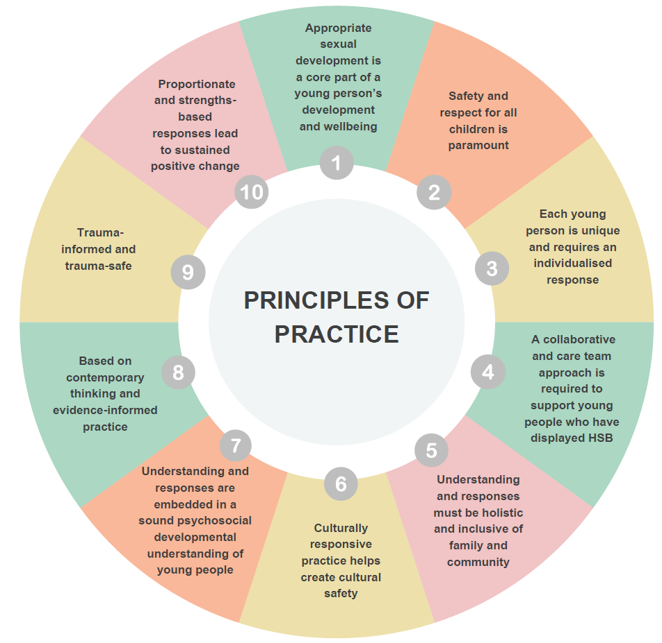
Figure 3: Principles of Practice for Understanding and Responding to HSB (Source: Paton et. al., 2024)

Understanding Mandatory Reporting Obligations
In Western Australia, certain professionals must report child sexual abuse by law. This is called mandatory reporting. Currently, doctors, nurses, teachers, police officers, midwives, boarding supervisors, ministers of religion, out of home care workers and assessors, psychologists, and school counsellors must report if they believe a child has been or is being sexually abused. This includes abuse by another child or young person. They must report this if they learn about it during their work, whether they're paid or not.
The government is planning to add more people to this list. Soon, youth justice workers, and early childhood workers will also have to report child sexual abuse. These changes will be completed by May 2025. Completion of these tools support individuals to understanding if sexual behaviour they have observed in a young person is worrying, but though do not replace mandatory reporting requirements. Required reporting must occur alongside completion of these tools where required.
Alongside mandatory reporting obligations, in some event of imminent risk or in instances where HSB has impacted a child or young person, an emergency services response may be required, either by calling 000, the local mental health emergency service or by taking the child to the emergency department. Organisations may also have processes and policies that need to be followed in these situations. If in doubt, it is best to seek advice from the organisation who manages the child or young person’s care.
These tools do not impact on your mandatory reporting requirements. At some points, the tools will prompt you to consider your mandatory reporting obligations. The tools provide guidelines for practice responses only and should be completed alongside your existing organisational processes and legal obligations.

Cultural Considerations
When working with children and young people who may have displayed potentially harmful sexual behaviour, it's important to consider cultural and religious differences and how these might impact on the child’s behaviour. People from different cultures and religions view and talk about sexual behaviour in many ways.
When working with children and young people who have experienced HSB, it is a good idea to ask the children, young people, and their families how they understand these behaviours. By being open and curious, inaccurate assumptions can be avoided and help everyone feel understood. This information will help everyone involved in the child’s care understand how to work with the child and their family to ensure safety.
It's especially important to seek cultural advice when considering HSB impacting Aboriginal children and young people. Studies show that Aboriginal children over ten years old are much more likely to be charged by police for sexual or violent offences than non-Aboriginal children. Seeking cultural inputs can help to ensure that behaviours are being properly interpreted and that the right supports are in place for the child or young person.
It's okay to be uncertain about cultural issues related to HSB, but it's important to know when to seek additional advice. The Response Mapping Tool suggests when to ask for advice from cultural experts. This will help ensure cultural factors are considered when developing plans to support children and young people to remain safe and well.

Compassionate Approaches to Response Mapping
To fill in the HSB Response Mapping tools, it is helpful to use information that has seen and heard to help guide responses. Sometimes, discussion with the child or young person may be required to help understand the situation and their support needs. When talking to them about HSB, it's important to be kind and empathetic, and consider how the adults around them can walk alongside them to support them to make safe choices. Make sure they have the right support, including additional help from their own culture and their caseworkers if needed.
If discussions with the child or young person about harmful sexual behaviours do occur, it is important to have a plan ready to get them more help if they need it. Tell them they're in a safe place and really listen to what they say. It is important to remain calm within these conversations and give the child time to talk without rushing them. It's also important to consider that these conversations can be impactful for everyone involved in them, and additional supports may also be required for the adults around the child.

Other Important Guidelines and Frameworks
The Level A Checklist and Level B Review are based on a framework known as the Layered Continuum Model for Understanding and Determining HSB (“The Layered Continuum”, Paton & Bromfield, 2024). Learn more about The Layered Continuum by watching this video about the Layered Continuum here.
The tools can be downloaded and saved either as a Microsoft Word or PDF File for completion. Copies may also be printed and filled in by hand if that is easier. Printed copies can then be scanned for sharing with the child or young person’s care team or caseworker. They build on existing Department of Communities policies and procedures.
These include (but are not limited to):
- Department of Communities Framework for Understanding and Responding to HSB (2022)
- Western Australia's state-wide Framework for Understanding and Responding to Sexual Behaviour. (pending)
- Stability and Connection Planning policy.
- Western Australian Therapeutic Care Service Framework
- Child Protection Guide.
Each agency and/or service context is likely to also have individual policies and procedural guidelines related to this area which should be considered.

UNDERSTANDING AND IDENTIFYING HSB
When caring for, or supporting, a child or young person who is displaying sexual behaviour, it can be hard to determine if their behaviour is developmentally normal, and to know if they require any support for this behaviour.
The HSB Response Mapping Tools help guide carers and the child or young person’s care team to consider a child or young person’s sexual behaviours. They provide a way to record and consider this information to help effective responses to support the child or young person’s wellbeing.

Level A Checklist: Identify and Respond
- Level A Checklist - birth to 3 years
- Level A Checklist - 4 to 6 years
- Level A Checklist - 7 to 9 years
- Level A Checklist - 10 to 11 years
- Level A Checklist - 12 to 14 years
- Level A Checklist - 15 to 17 years
All versions of the Level A Checklist can be accessed here.
The Level A Checklist is designed for carers and others in children and young people’s lives to complete when they observe or become aware of sexual behaviour of children and young people in their care. They can be completed by anyone who observes a sexualised behaviour which they are concerned about, including kinship and foster carers, residential carers, and other professionals around a child or young person.
The Checklist can be completed without any prior knowledge of HSB. Multiple versions of the tool are available, each tailored to different developmental stages. This helps the user accurately map the observed behaviours to the Layered Continuum, taking into account the child or young person’s developmental capacity.
This tool can be completed multiple times and should be re-completed if additional behaviours occur, or situations change for the child or young person. The tool supports carers to consider how developmentally appropriate a child or young person’s behaviour is, and to seek appropriate supports for the child or young person.
Once a Level A Checklist tool is completed, the tool provides a suggested response to the level of concern based on the information used to complete the tool. The response may be to continue monitoring the child or young person’s behaviour, to seek additional support through a referral to the child or young person’s case manager, and/or to work with the child or young person’s care team to develop a safety plan.
When there have been 2 or more Level A assessments (regardless of outcome), or a single Level A assessment which was rated as Concerning, Very Concerning or Serious/Extreme, a Level B Assessment should be completed within 2 weeks.

Level B Assessment: Review and Enhance
Level B Assessment
The Level B Review is designed for case managers or similar to complete when they receive multiple Level A forms, or when they receive information about sexual behaviour that is classified by the Level A tool as Concerning, Very Concerning, or Serious/Extreme.
The Level B tool includes information about the child’s previous history and directs the case manager to consider actions and follow up procedures to enhance safety and the provision of supports to the child or young person and their placement. Depending on the information entered, the tool may direct the case manager to build a long-term plan to enhance the child or young person’s wellbeing and safety that could include specialist referrals.
Generally, the child or young person’s case manager or the equivalent lead within an agency will be best placed to lead completion of the Level B Review, though discussion within the child’s care team should occur to confirm this. Completion of the Review should occur in consultation with the child’s care team and other key stakeholders in the child and young person’s life to ensure thorough consideration is given to their situation, including exploring any related cultural, trauma, developmental and other situational factors that may impact on sexualised behaviours. The review should also consider any Level A Checklists that have been completed for the child over the last 6 months, integrating past behaviours collectively.
When the child is Aboriginal, or from a culturally, linguistically, or religiously diverse background, it is essential to seek input and review from an appropriate cultural advisor. For Aboriginal children, this may include consultation with Elders, kin, or a suitable Aboriginal Registered Organisation familiar with the child or their family. This ensures that the outcomes of the Review are culturally informed and respectful of the child's background and identity.

Sharing and storing of the tools
Remember even if only a Level A Checklist is completed, that information about a child or young person needs to be safely stored in line with organisational policies or those of the child’s care provider. It is suggested that the completed tools be shared with the child’s caseworker to ensure the child or young person continue to receive the support they require.

Key Points to remember:
- The Level A Checklist is a tool for quickly identifying and noting sexual behaviours of concern displayed by a child or young person.
- The Level A Checklist can be completed by anyone who observes a sexual behaviour of concern.
- The Level B Assessment is completed by the case manager, or equivalent, when a Level A Checklist has identified serious concerns or if multiple Level A Checklists have been completed in the past 3 months.
- The Level B Review provides a deeper understanding of the behaviour to enable a targeted and supportive response plan.
- These tools should be appropriately shared with the child or young person’s care team to ensure the right supports are provided.

ENHANCING SAFETY
Enhancing safety for young people who have displayed HSB, and those around them is an essential next step following an assessment of risk related to this issue. As with risk, there are a variety of elements that can contribute towards enhancing safety, including those related to the young person themselves, the environments, and the supports in place around the young person.
When enhancing safety, it is important to be aware that children and young people distinguish between feeling safe and being safe (Moore et. al., 2016). In the context of HSB, it is important to understand that sexual behaviour is a part of children and young people's normal development, and in appropriate contexts, children and young people's sexual behaviour can be normative and healthy.
Enhancing safety within the context of HSB should include a plan to ensure immediate, acute, and short-term safety, as well strategies to enhancing safety and wellbeing and build strengths in the longer term. There are also key principles and processes that should be considered when developing safety plans.
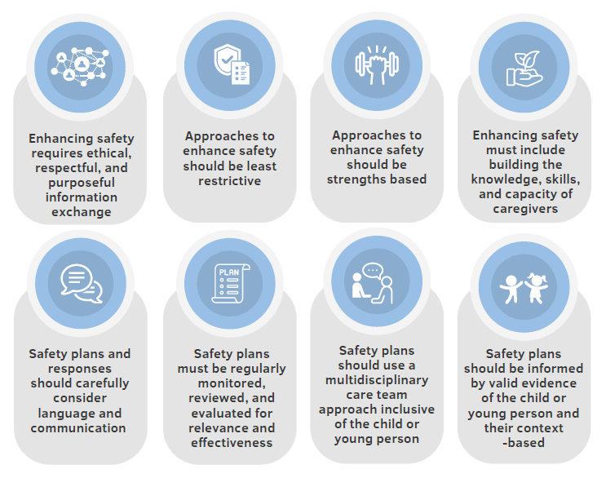

Figure 4. Factors required to enhance safety over time – building strengths and protective factors (Source: Paton et al., 2024)

The Acute Safety Plan
Acute Safety Plan
The Acute Safety Plan assists caregivers and care team create a structured and supportive approach to enhance the safety and well-being of all children within the home environment by addressing and reducing harmful sexual behaviours. This plan aims to identify current areas of concern, identify areas of strength, and provide targeted strategies and resources to support appropriate behaviour within the home and promote healthy relationships.
The Acute Safety Plan should be completed by the child or young person’s case manager, or equivalent, and occur in consultation with their carer, broader care team and other key stakeholders in the child and young person’s care team and life. Involving the child or young person in the safety planning process assists to empower them and build trust and engagement with the plan. Their input also provides valuable insights into their unique needs and helps to create a more relevant, sustainable, and effective plan for safety.
Depending on the age and needs of the child or young person, the information in the Acute Safety Plan may be simplified and presented within the child friendly version of the form.
This resource must be regularly reviewed to ensure it remains relevant, incorporates least restrictive practices, and recognises any changes in the child or young person's needs or behaviours.
Additional safety planning may be needed for other environments where the child or young person spends significant time, such as school or sporting activities. These plans should address the specific context of each environment and cover similar areas as the main safety plan, including supervision, privacy, media use, and behavioural expectations.

Sharing and Storage of the Resources
The Acute Safety Plan should be safely stored in line with organisational policies or those of the child’s care provider. To ensure the plan are easily implemented in the child or young person’s daily life, the completed tools should be made accessible to both the child or young person and their caregiver within the home environment.
If Acute Safety Plans have been developed for other settings where the child or young person spends time, copies should also be provided to the relevant external representative of those environments (i.e. school principal).

Key Points to remember:
- The Acute Safety Plan is designed to enhance immediate and short-term safety. It requires regular review and is not ‘set and forget’.
- The Acute Safety Plan is completed by the child or young person’s case manager (or equivalent), with input from the carer, broader care team, and other key stakeholders in the child or young person’s life.
- Involving the child or young person, where appropriate, provides insights into their unique needs, ensuring the plan is relevant, sustainable, and effective.
- Copies of these resources should be made accessible to the child and caregiver.

Children and Young Person’s Version of the Safety Plan
The Child and Youth Version of the Safety Plan is a form specifically designed to be completed and kept by the child or young person. It serves as a personal tool they can use when they feel the urge to engage in HSB, helping them identify strategies to stay safe and make positive choices. Like the Acute Safety Plan, this form should be reviewed regularly to ensure it remains relevant and effective as their circumstances and needs evolve.
To ensure these plans resonate with children and young people, we’ve developed multiple versions of the form that cater to different ages and image preferences. The child or young person can choose the version they like best or even create their own, using the suggested questions as a guide.
Safety plans should always be completed together with the child or young person by their caregiver, case manager, residential worker, or therapeutic practitioner. It is essential to use the child or young person’s own words in the plan to make it truly meaningful and relatable to them.
Once completed, the child or young person should have ownership of their plan. They can keep a hard copy, take a photo of it to store on their phone for easy access, or other means of access suitable for the child or young person.
Templates available:
- My Safety Plan for children - bright cartoon people
- My Safety Plan for Children - super hero design 1
- My Safety Plan for Children - super hero design 2
- My Safety Plan for Children and Young People - Simple
- My Safety Plan for Young People - graffiti design
- My Safety Plan for Young People - simple colour design
- My Safety Plan Young People - plain

The templates can be accessed here
The table below includes some additional information to help guide the carer, residential worker, case manager or therapeutic practitioner through things to include in the Safety Plan for a child or young person.
Table 1: Things to include in the children or young person’s copy of the Safety Plan
Question/ Domain | Things to consider
What are we worried about? | What behaviour, situation and/ or context is the young person, child, or care team worried about. there may be differences here between what they are worried about and what the care team is worried about. This is a great opportunity to explore this more with the child or young person. Make sure this section is about the behaviour and not labeling of the child or young person – try and be specific.
What are the signs that these behaviours might occur? | Try and support the child or young person to identify, feelings, situations, or things that happen just before the behaviour – you might be able to support a young person to understand these as ‘triggers’ if this is helpful. remembering though, sometimes finding triggers for behaviours may take time, and not be immediately apparent. if this is the case, you could try get them to think about the last time the behaviour of concern occurred and include some of these things. This is a great opportunity to help them learn more about their behaviour.
My go-to safety tips | Brainstorm together things that can be used as preventative strategies that integrate with the Acute Safety Plan - general safety behaviours. These can also include distress tolerance strategies. Try and identify with the child or young person strategies, or safety tips for the home, school, when with friends and when on-line.
Who’s in my support team? | Help the child or young person identifying trusted support network members. These may be from their care team or broader support network.
How can my support team help? | Try and be specific, draw from the Acute Safety Plan and list some activities, statements, prompts that each person can do. This may be a subtle reminder, a non-intrusive phrase, or something more active like playing a game, or going for a run with the child or young person.
Other resources or people I can reach out to? | Include here other people, helplines and support websites that may be helpful if the child or young person’s support team are not available.

Sharing and Storage of the Resources
The Child and Youth Version of the Safety Plan should be provided to the child or young person using a method preferred by them, as described above. At the same time, it’s important to remain mindful of privacy and confidentiality in this process. It is also useful to share a copy of this form with the child or young person’s caregiver/s to enable them to support it’s use. A copy of the form should also be safely stored in line with organisational policies or those of the child’s care provider.

Key Points to remember:
- The Child and Youth Safety Plan is designed as a personal tool for the child or young person to use when they feel the urge to engage in harmful sexual behaviours (HSB).
- The Plan should be reviewed regularly to ensure it remains relevant and effective as their circumstances and needs change.
- The plan should be completed together with the child or young person by a caregiver, case manager, residential worker, or therapeutic practitioner.
- Once completed, the child or young person should have ownership of their plan.

Enhancing Safety and Wellbeing Plan
Enhancing Safety and Wellbeing Plan
The purpose of the Enhancing Safety and Wellbeing Plan is to enhance the safety and well-being of the child or young person over the longer term as a means of reducing future engagement in harmful sexual behaviours. The plan offers a structured approach to supporting growth and connection in key areas that contribute to safety and well-being. It does so through targeted goals, actionable steps, and regular evaluations over time. By integrating family involvement, community resources, and personalized interventions, this document seeks to foster a holistic development environment that promotes healthy sexual behaviour and relationships, adaptive skill-building, and overall well-being.

Sharing and Storage of the Resources
Both safety resources should be safely stored in line with organisational policies or those of the child’s care provider. To ensure the plans are easily implemented in the child or young person’s daily life, the completed tools should be made accessible to both the child or young person and their caregiver within the home environment. If Acute Safety Plans have been developed for other settings where the child or young person spends time, copies should also be provided to the relevant external representative of those environments (i.e. school principal).

Key Points to remember:
- Enhancing safety is an essential step in reducing risk in the short and long term.
- The child or young person and other key members of their care team should provide input into any plans to enhance safety.
- The Acute Safety Plan is designed to enhance immediate and short-term safety. It requires regular review and is not ‘set and forget’.
- The Enhancing Safety and Wellbeing Plan aims to build safety and wellbeing for the child or young person over a 12-month period using actionable steps and strategies.
- Copies of these resources should be made accessible to the child and caregiver.

REFERENCES
Attorney-General’s Department. (2023). National Strategy to Prevent and Respond to Child Sexual Abuse (2021–2030): First Annual Report 2023. Canberra: Australian Government. childsafety.gov.au
Department of Communities. (2022). Framework for understanding and guiding responses to harmful sexual behaviours in children and young people. https://www.wa.gov.au/system/files/2022-07/Framework-Understanding-Guiding-Harmful-Sexual-Behaviours.pdf
Moore, T., McArthur, M., Roche, S., Death, J., & Tilbury, C. (2016). Safe and Sound: Exploring the Safety of Young People in Residential Care: a Report for the Royal Commission Into Institutional Responses to Child Sexual Abuse. Institute of Child Protection Studies.
Paton, A., & Bromfield, L. (2024). Understanding Harmful Sexual Behaviours: A Layered Continuum, University of South Australia, Australian Centre for Child Protection: Adelaide.
Paton, A., Horch, G., Ibrahim, N., & Winslade, K. (2024). Literature summary of key themes for enhancing safety and creating safety plans. Australian Centre for Child Protection, University of South Australia: Adelaide.

